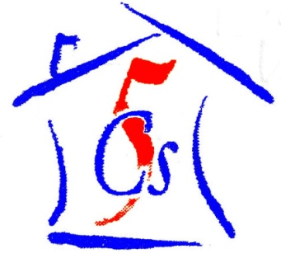
Chernobyl Children Cancer Care Cardiff
53 Heol Llanishen Fach Rhiwbina Cardiff CF14 6LB
Tel: +44 (0)29 20624730
www.five-cs.org info@five-cs.org

Registered Charity Number: 1077451
It has been 6 months since the last newsletter and it has been a busy time for us here at the Five C’s. First and foremost the Summer Camp Project was an outstanding success once again with a total of 30 volunteers travelling to the summer camp in Zabrodie to participate in the project, either as a child care volunteer and being a part of the fantastic international team that looks after the children or as a maintenance volunteer, maintaining the grounds and buildings of the camp, keeping it looking vibrant and beautiful.

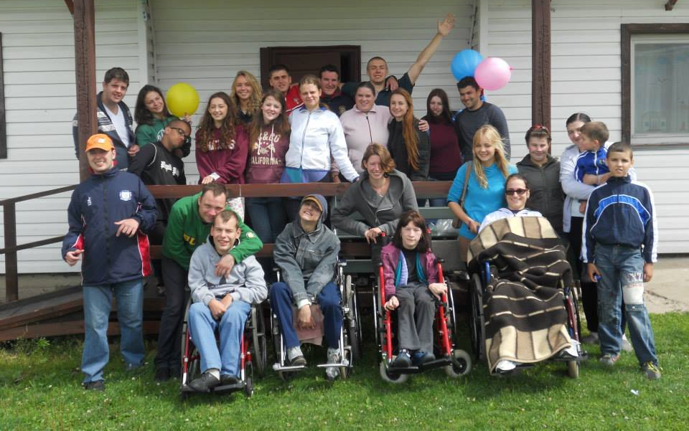
We have had some amazing feedback about our volunteers from the Belarusian Children’s Hospice staff. The summer would not have been the success that it was without all their hard work and dedication. A huge thank you for everything that you do. We hope that you have enjoyed yourselves as much as we are sure the children have.

The maintenance group worked tirelesly to maintain the camp and they made some major headway with the clearing of a plot of land that we bought last year where the new multi purpose Volunteers House will be. The foundations are set to be built by the end of the year.
Future fundraising will be done to finish the house with ideas already flowing fast!
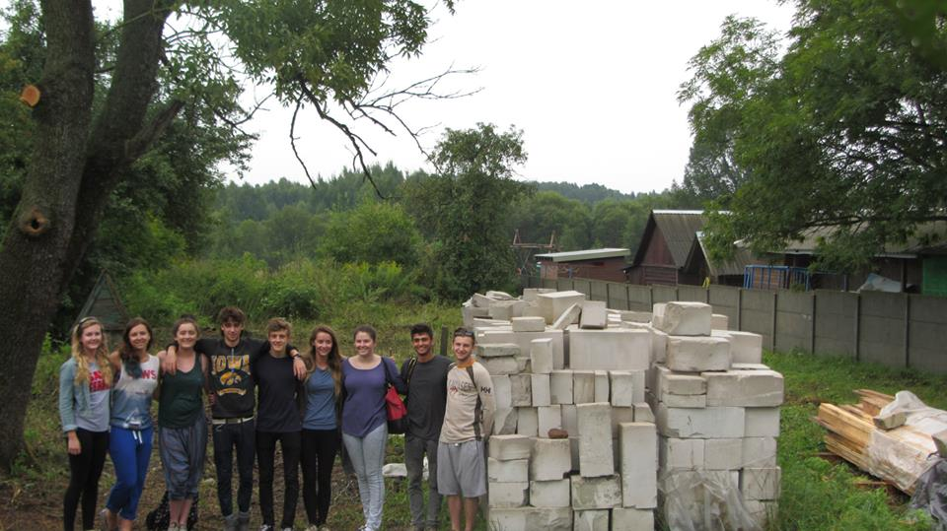

While we were all busy in Zabrodie volunteering on the camp, once of our members, Tony Powell completed a challenge of a lifetime when he cycled from the lowest to the highest point in Wales, from Cogan to the peak of Snowdon. It was a gruelling 240 miles over 5 days and a huge thankyou goes to him for all his efforts in raising £1360!
We had our AGM just a few weeks ago and are proud to welcome new members to the team, this year our membership list is at 53, with 40 of them being students and 45 of them under 25-proof of the incredible young people there are out there!
The Five C’s family is growing rapidly and the work we do along with it- we are so happy to have everyone on board and we are looking forward to another year!
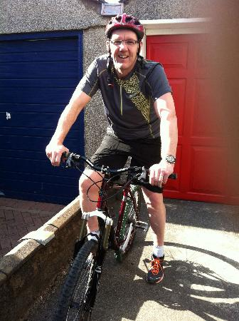

We are extremely grateful for all the support that we get, thanks to the Rotary Club of Cardiff Breakfast and the Interact Clubs of Whitchurch and Howells schools that once again supported us all year. Thanks also to all the local businesses and residents who support us, a special thankyou goes to those who have done sponsored events on our behalf. Team leader Owen Moon completed the Tough Mudder challenge raising over £150, team leader Bethan Sexton’s mum ran a cocktail and tapas evening rasing over £400, and a friend of the charity, Kyle Greck shaved off his very long locks and raised over £400 too.
It is because of these efforts that work has been able to be started on the new volunteer house in Zabrodie less than one year after we bought the land!

Please see our website at www.five-cs.org, our Facebook page (search Chernobyl Children Cancer Care Cardiff) or our Twitter account (@FiveCsCardiff) for more detailed and up to date information, photos, contact information and where you can donate safely.

Don’t forget to remember us while you shop by registering on www.easyfundraising.org.uk- it won’t cost you anything! Thank You!

Zac and Beth

